Budget & Academic Policy Committee
College of Education, Health & Human Services (CEHHS)
Minutes – September 3, 2019
12:00 PM - 1:30 PM in UH 449

Committee Members:
X | Laurie Stowell  School of Education |  | Amy Carney  School of Nursing
X | Erika Daniels  School of Education | X | Lori Heisler  At-Large
 | Matthew Schubert  School of Health Sciences & Human Services | X | Shannon Cody, Director  CEHHS Student Services (Non-voting)
X | Teru Toyokawa  School of Health Sciences & Human Services |  | Vacant  Staff (Non-voting)
X | Susan Andera  School of Nursing | X | Deborah Kristan, Associate Dean  CEHHS (Non-voting)

CALL TO ORDER
Establish quorum: Yes
APPROVAL OF AGENDA
Moved to Approve as Amended: Lori Heisler
Seconded: Laurie Stowell
Unanimously Approved

APPROVAL OF MINUTES
Moved to Approve:
Seconded:

OLD BUSINESS:

NEW BUSINESS:
Budget allocations overview
- (Kristan) Connections to three-year rolling plan and EL share allocations
  - Base and Salaries are complete and the response to the three-year plan will be sent out this week so CEHHS will know what was approved.
  - No FTEs growth, but our college will receive growth funds as dictated by the President’s Office. In fact, the college’s FTEs dropped by 1.2% due to degree planner.
  - EL share allocations are being reformatted and sent out to the units within a few weeks.
  - Nursing questioned how to grow a new stateside program, like their planned DNP, with the FTEs restrictions. It was suggested to submit a proposal explaining the regulatory and Chancellor pressures upon the school for the program being forced stateside to the Provost’s.
  - Any specific directions for BAPC?
    - Dr. Kristan noted BAPC was the keeper of the three-year plan and making changes, but ultimate decision authority for BAPC’s future lies with the committee.

CEHHS meeting with President Neufeldt
- Listening and Learning Tour
  - Amy Carney and Lori Heisler volunteered.
- Need a representative for September 20, 12:30 – 3:30

Role of BAPC in College faculty governance
- Review committee charge
  - Members were encouraged to go to their units and ask for their input on how they envision BAPC’s role with the revenue share (19.20) and profit shares (moving forward).
  - Increasing allocation to lecturer development and travel. Discussion surrounding how to facilitate additional funding and the rubric to approve and weigh lecturer requests.
- Work with CCC and Dean’s Office to revise
  - Goal is to have a workable draft of the vision and bylaws of BAPC for the college and CCC by December or late November.

Action Items:
- Dr. Daniels will work with Malachi to have Zoom meetings set up for faculty that are unavailable or stuck in ELB due to schedule conflicts.
- Members are asked to review the changes to the bylaws for BAPC and be prepared to discuss them at the next meeting. They are stored in SharePoint at this location: https://csusm.sharepoint.com/:w:/r/sites/college_of_education_health_and%20_human_services/deans_office/administration/Shared%20Documents/Governance/Standing%20Committees/Committee_BAPC/agendas_minutes/AY%202018-19/Charge%20%26%20Bylaws/BAPC%20Charge%20%26%20Bylaws_Draft_20181106_NoMarkUpsShown.docx?d=w6d35f34cc6ee42c8bbf3980b36920a16&csf=1&e=ehgVeI
- Members are asked to review the allocations presented by Dean Ayala at Fall Convocation (included below) with their units and bring feedback and suggestions regarding items labeled TBD/BAPC/CCC.

Current allocations from Dean’s All College presentation for your information:
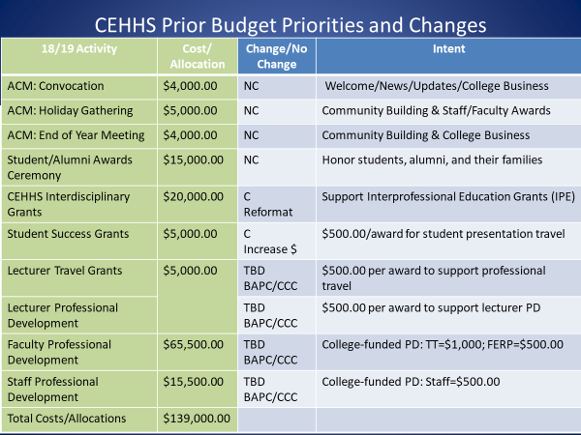

Adjournment: 12:58pm

