California State University San Marcos
Fall 2009 Alumni Survey

In Fall 2006, Institutional Planning and Analysis, in cooperation with the Career Center and the Development Office, developed an electronic survey that was sent to alumni who graduated from California State University San Marcos prior to Fall 2006. The same survey has been sent annually to students who graduated three years earlier and to our most recent graduates. This fall we sent 2,290 surveys to 2005-06 and to 2008-09 graduates; 323 were returned yielding a responses rate of 14.1% (10.1% of total graduates).
Analysis suggests that the response sample is largely representative of the larger group of graduates with one exception: nearly all respondents are recent graduates. Consequently, this report will focus on the responses of 2008-09 graduates with results presented longitudinally by graduation year and, if appropriate, by highest degree earned at CSUSM and level of involvement in campus activities while attending CSUSM. The survey focuses on three areas: participation in alumni activities, employment and educational activities since graduation, and views on curricular features at CSUSM.
Nearly all respondents earned their Bachelor’s degree from CSUSM and 11% earned more than one degree from our campus. The most common major among respondents was in a Social Sciences discipline followed by Business; one in ten respondents earned a credential.
As in previous surveys, nearly all respondents say they are proud to be a Cal State San Marcos graduate and three-quarters say that their years at CSUSM were some of the best of their lives. Many respondents echoed the sentiment expressed by one respondent:
Overall, I had a wonderful experience at Cal State San Marcos. It’s a wonderful campus and my professors were wonderful. I met new people that became some of my good friends. It truly was a great experience and I am truly honored that I received my Bachelors degree from this university.

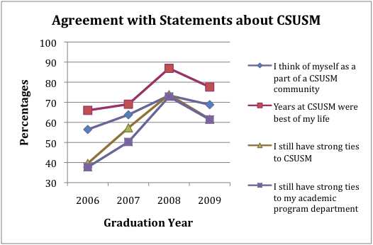
The percentage of respondents who reported positive memories of their time at CSUSM had been steadily increasing over the years, but dropped in all areas in 2009. In spite of this drop, 60% reported at least some involvement with the university since they graduated—up from 40% or less in previous years. As was true in previous surveys, respondents who participated in activities while they were in school are more likely to have positive associations with the university.
Respondents to this year’s survey were less likely to say they have recommended the university to others (59% vs. 75% of last year’s respondents). They are more likely than previous respondents to have used the Career Center and to have attended campus events during the past year but less likely to say they plan to do so in the future.
The percentage of respondents who are employed has been declining for the last 2 years and just 39% of 2009 graduates say they are working full time. Of the 27% who are unemployed, 16% are actively seeking employment at this time. Furthermore, two in five respondents continued in a position they held before they graduated, a percentage that is higher than reported in previous surveys.
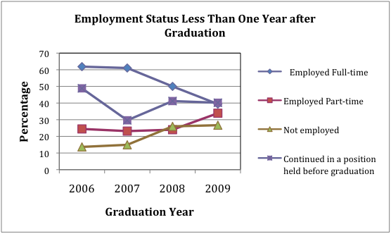
Respondents’ expressed this concern with comments such as these:
No jobs. Bad time to graduate.

My time at CSUSM was great- but I think more career advising would have benefited me more. Sure there were seminars on how to write a resume and how to do interviews- but when you have papers, projects and exams to prepare for- these things take a back seat- and usually get left behind until its too late to perfect these skills. My suggestion- is to make it mandatory- for students to have classes or seminars in- how to search for jobs, how to write resumes and how to do interviews. This at least ensures that when students leave school- they know how to do these things.

Only one-quarter of Bachelor’s recipients report making more than $40,000 per year and one-third say their current job is not in line with their career goals.
Finally, respondents were somewhat less likely to be working in North San Diego County than in previous years.
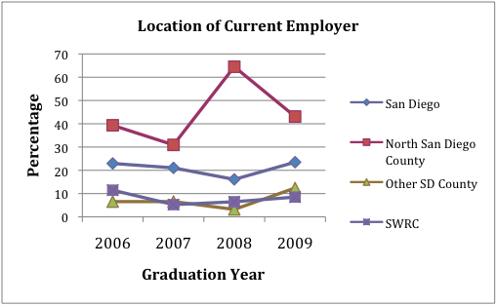
More than half of respondents plan to attend graduate school and 20% are currently enrolled in a postbaccalaureate program—about the same percentage as previous years. However, this year’s respondents are more likely than earlier survey respondents to say they plan to enroll in graduate school within 2 years (47% vs. 14%).
Respondents are very positive about the utility of the skills they gained from their coursework at CSUSM. The majority said their writing skills, critical thinking skills and speaking skills, as well as their ability to work as part of a team were enhanced by their education and these same skills have been useful to them since graduation. As one respondent commented:
Another great aspect of CSUSM was the writing requirement, although I didn't care for it much at that time :) As I'm out in the working world I now see how many professionals are out there that really do not write well.

In many ways survey respondents reflect the current economic times. Recent graduates seem less happy with their college experience than in previous years, and are less likely to recommend CSUSM to others and less likely to be employed.

A special thanks to Alumni Services for providing the email addresses of our alumni. Of the 3,081 graduates, we were able to successfully contact 2,290 of them (74.3%).
The last question in the Fall 2009 Alumni Survey invited respondents to make additional comments about their “experience at CSUSM and the utility of the undergraduate education you received.” Eighty-three respondents took advantage of this opportunity.

