The Search for Gold
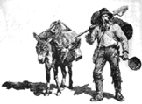
Most of the fortune seekers in the California gold rush were young men. These 49’ers left behind families and jobs in the hope of becoming rich right away and never having to work again. Most did not get what they had hoped for. It was not uncommon when the gold rush began in the early days (in 1848-1849) for a minor to dig up $2,000 of gold in one day! But most might have been lucky to find $10.00 of gold in one day. As California flooded with people from around the world, the easy surface gold was gone quickly!

Miners suffered many hardships. Digging for gold was extremely difficult and dangerous. Large numbers of miners died while they were digging. Many died from diseases, or from accidents such as drowning in a river.

Camping and Housing
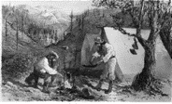
Most miners lived in tents and cooked their food over an open fire. Meals were usually beans, bacon or local game. Every day food items were very expensive. In addition, the food was not very nutritious and many had poor health. Scurvy was common from lack of fruits and vegetables. Sickness and colds were common from sleeping on the frigid, damp ground. Sanitation was poor and miners seldom bathed or washed their clothes.

Most camps and mining towns were canvas tents or wooden buildings. Fires were very common. Many camps and towns were completely destroyed by fire, some several times. Winter time in the camps brought snow and heavy rain which made for very rough conditions. Therefore, most miners went back to San Francisco for the winter, or stayed in a mining town where the weather was better.

A gold miner named Shufelt lived in a cabin with six other miners. The cabin had windows, a fireplace and an oven. Like other miners, they had a very poor diet and suffered from scurvy and other diseases. Shufelt became seriously ill and was not expected to live. He did recover however, and wrote home about life in camp. “Many, very many, that come here meet with bad success and thousands will leave their bones here. Others will lose their health, contract diseases that they will carry to their graves with them. Some will have to beg their way home and probably one half…will never make enough to carry them back.”

Family, Friends and Entertainment
Some families made the trip to California, but most families stayed at home. The trip was very expensive for each person and was considered too rough for women and children. Miner’s planned to strike it rich and return home before long. The homesick miners formed friendships and communities with other travelers. Card games, gambling and betting were common ways to pass the time. Unfortunately, some of the miners drank too much alcohol, and did not make good decisions. Too much drinking and gambling led to fighting and chaos in the mining towns.

Society and culture was needed as the population grew. Musicians traveled to mining camps. Canvas theaters were set up and miners were entertained by groups of musicians, singers, child actors, a Shakespeare performance, or even fights between grizzly bears and bulls! In the cities, large halls and theaters were built.
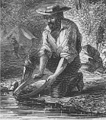
The Effects of Mining Technology
At first, 49’ers “panned” for gold (photo on right). This was the simplest way. Each prospector would have his own pan down at the river and swirl a combination of water, gravel or sand. Then they would blow on the lighter rocky material so it would spill out. Some 49’ers struck it rich, but most were lucky if they made enough to eat. Within a few years, they didn’t have much luck with this method and panning for gold was no longer profitable.

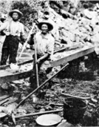
Miners continued to invent fast and more efficient ways to find gold. The “Long Tom” as pictured on the left, was meant to separate the gold from the gravel with miners working together. It took four men and lots of moving water to operate a Long Tom. Ditches were dug to direct the supply of water toward the Long Tom which was placed close to the riverbank. Gravel would be shoveled into the first part of the Long Tom and another miner would remove larger rocks from the trough as the gravel was forced downward by the stream of water and gravity. Screens placed along the Long Tom would catch the finer gold.

Another method was called hard rock mining. Much of the gold was inside quartz rock, which was deep within the mountains. The hard rock miners built tunnels and made them strong by cutting down trees and using the timber to hold up the sides. They worked thousands of feet below the surface, getting down in what looked like an elevator. They had to crush the quartz to separate the gold. They also used mercury to help separate the quartz from the gold. Mercury is very toxic and it killed fish and wildlife after it was washed into the rivers and the San Francisco Bay. There are still large amounts of mercury in the area from the Gold Rush days! Furthermore, the mines were extremely dangerous. There were cave-ins, explosions, and poisonous fumes that injured and killed many miners.
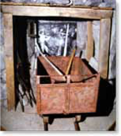

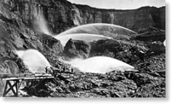
Finally, hydraulic mining changed the land and life of miners more than anything else. Miners were making very little money so many went to work for large mining companies. They used large nozzles that would shoot out up to 25 million gallons of water in one day. This is as much water to fill 1,250 backyard swimming pools! The hydraulic machine looked like a cannon. It could blast the mountains leaving huge craters. This was an efficient way to get to the gold. Gravel was washed through sluices (a kind of sliding gate) and the heavy gold settled into slats of wood in the sluice. The rest of the mountainside was washed into the streams and rivers. The countryside of California was torn up as newly arrived settlers searched for gold.

Farmers and Merchants
Farmers were very upset because their grain fields and orchards were ruined. Grain ships couldn’t navigate rivers because they were being filled by the gravel from mining. The mining companies ignored the farmers and refused to stop their search for gold through hydraulic mining. It wasn’t until over forty years after the Gold Rush began that the farmers finally won in court. A new law was established that made the dumping of mining materials in rivers that could reach farmlands or used by ships against the law. Unfortunately, other rivers were still used as dumping grounds for the mining “trash”.

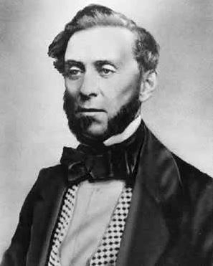
Merchants in California were more likely to get rich than prospectors. They charged very high prices for food and supplies. Samuel Brannon lived in Sacramento and was an example of someone who profited in a big way. He opened a store at John Sutter’s Fort, close to where the gold was first discovered. Rumors were going around that gold had been found nearby, so he headed to the mines and saw that it was true! He packed some of the gold into a small bottle and traveled over one hundred miles to San Francisco. As soon as he stepped off the river ferry he began waving the bottle and shouting, “Gold! Gold! Gold from the American River!” People from San Francisco immediately traveled to the area in Sacramento to get supplies from his store and find gold nearby. Brannon made a huge amount of money as more and more miners came to purchase what they needed to mine for gold. He opened other stores and soon became the largest landowner in Sacramento.

San Francisco became a “boom town”! In the year 1850, the population in California grew from 18,000 to 92,600! Disappointed migrants who were enterprising began businesses that fed, entertained and housed the region’s growing population. Over the years, San Francisco was much more than just the “landing place” on the way to find gold in the Sacramento area. The city became a major port, shipping grain and other agricultural products to the entire world. Some said that grain became the new gold! California became respected as an important state in the United States due to the agricultural business that grew in the Central Valley. Eventually the transcontinental railroad connected San Francisco to the east coast. It all began with the Gold Rush!

Sources:
http://explore.museumca.org/goldrush/fever19-ha.html
http://nationalgeographic.org/news/after-gold-rush/
http://www.eyewitnesstohistory.com/californiagoldrush.htm
http://www.kidport.com
cagoldrush.com

