Immigrant, Migrant and Native American Miners

With ships, equipment and thousands of ‘49ers pouring into California, San Francisco quickly became the most culturally and ethnically diverse place in the world.
During the early days of the gold rush everyone expected to get rich ~ and quickly! There was not a lot of competition because miners believed that there was plenty of gold for everyone. When gold became more difficult to find, miners became frustrated. They were jealous of anyone who was different, or whom they thought of as foreigners when they found gold. They seemed determined that non-Americans would get no part of California’s riches. Chinese, Europeans, South Americans, Mexicans and Native Americans, who treated as “foreigners”, were driven out of mining camps and forced to set up camps of their own.

“Foreigners” and African Americans were not allowed to testify in court, and had to pay Foreign Miners Taxes which made it more difficult to make a profit on the gold once it became more difficult to find. Each ethnic group came to the Gold Rush for some of the same reasons, but each group responded to the prejudice and discrimination in different ways.

Chinese Miners

The Chinese heard about the gold rush and gave California a nickname, Gam Saan, or Gold Mountain, which meant the land across the sea. In China there was war, high taxes, floods, and famine. It sounded like a great idea to many men in China as they heard about opportunities for a better life. In a village in China, a sign was posted:

Laborers wanted for California in the United States of America. There is much work. Food and housing supplied. Wages are generous. There is no slavery. All is nice.

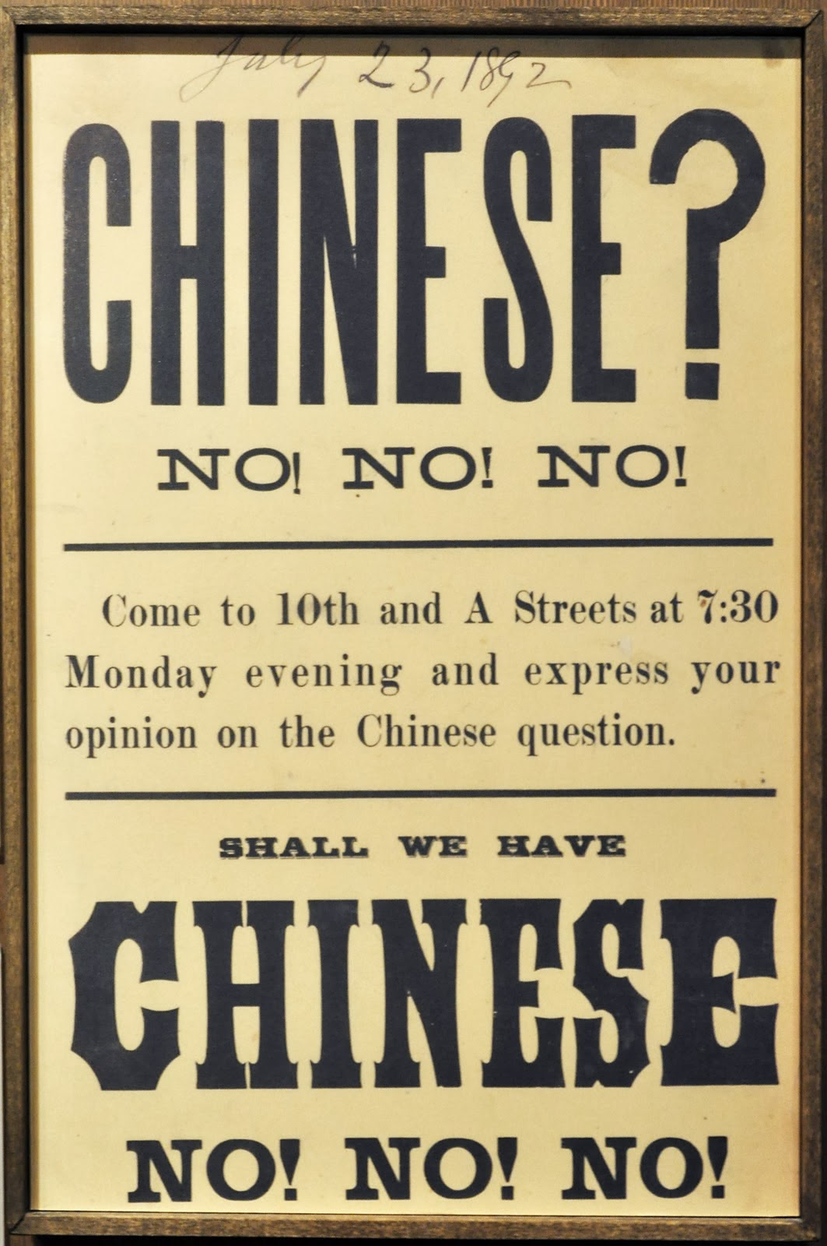
Soon the miners in the goldfields were unhappy about the competition from the Chinese miners and they chanted, “California for Americans!” The Chinese were prevented from becoming United States citizens. In America, they would be foreigners forever.

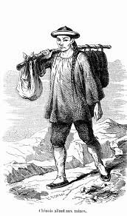
Most of the Chinese worked in the goldfields when they first came. They wore blue cotton shirts, baggy pants, and wide-brimmed hats, and looked much different than the California miners. The Chinese were hardworking and peaceful. They were willing to take lower paying jobs and some opened up their own restaurants, stores, hotels
and laundries. They usually sent their money home to their families.

A few years after the Gold Rush began, Chinese immigrants began to be treated terribly. Difficult economic times caused miners to feel disappointed and angry. They began to accuse the Chinese of stealing jobs and driving down wages. Anti-Chinese riots and attacks were very common.

“Hunted Chinese in the night. Had a great time.” Horace C. Snow

The government passed a second Foreign Miners Tax that really targeted the Chinese. This tax required Chinese miners to pay a fee of three dollars each month at a time when the Chinese miners were making approximately six dollars a month. Fake tax collectors made money by taking advantage of people who couldn’t speak English well, and some tax collectors stabbed or shot Chinese miners who couldn’t or wouldn’t pay the tax. The Chinese could not testify in court so it was impossible to prosecute violence against the tax collectors.

The Chinese were hard workers and very good with business. When they could not be successful with gold mining, they opened restaurants, laundries and hotels. Others sewed and repaired shoes. Having been experienced farmers in China, they shared their knowledge of agriculture, and the building of dams and watering systems. In later years, the Chinese went to work on the construction of the railroads. The Chinese immigrants who came to California to find a better way of life added a great deal to the development of California as an economically powerful state on the west coast.

http://explore.museumca.org/goldrush/fever15.html
http://www.pbs.org/wgbh/amex/goldrush/peopleevents/p_chinese.html
Takaki, Ronald. A Different Mirror. New York: Seven Stories Press, 2012
Takaki, Ronald. Strangers from a Different Shore. A History of Asian Americans. Boston: Little, Brown and Company, 1989
http://califgoldrush.weebly.com/chinese-immigrants1.html

Native American Indians
http://www.pbs.org/wgbh/amex/goldrush/tguide/index.html
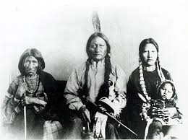
Just like the Chinese, California's native people faced prejudice and discrimination. Miners did not want the Native Americans to get any of the gold; they wanted it all for themselves. When ‘49ers arrived during the Gold Rush and set up their homes and businesses, many Indian tribes were forced from their ancestral lands. The natural resources they depended upon for food and shelter were destroyed.
They were not considered Native Americans, even though they had been on the land years before it had become “California”. Laws were written preventing them from voting, owning property or weapons of any kind, serving on a jury, or testifying in a court of law. Plans were organized by the United States government to massacre defenseless villages. The editor of the San Francisco Bulletin spoke for most white Americans, “It is a painful necessity of advancing civilization that the Indians should gradually disappear.”
California's natives very nearly did disappear. Besides direct violence against them, the ‘49ers brought diseases to California that were foreign to the natives and killed many of them. They had lived on their ancestral lands and supported themselves by fishing hunting, and gathering, and they showed extreme respect for the environment. However, this way of life had become nearly impossible. Their land had been ruined by gold mining; the rivers had turned brown from waste and chemicals.
Most Native Americans had to decide whether to stay in California and live a life of poverty and poor health, or leave the home of their ancestors.
Gold, Greed, & Genocide. “The Story of California’s 1849 Gold Rush. 13 Apr. 2012.
https://indiancountrymedianetwork.com/history/events/native-history-california-gold-rush-begins-devastates-native-population/
http://www.pbs.org/wgbh/amex/goldrush/sfeature/natives_04.html
.http://explore.museumca.org/goldrush/fever16-di.html
http://www.kumeyaay.info/california_gold/

Spanish Speaking Miners

Mexican miners often traveled with entire families overland to California to join the Gold Rush. They were surprised to find that they were considered foreigners ~ this land had just recently been their own. The Americans had just been given California at the end of the Mexican/American war ~ only days before gold had been discovered!

During the Gold Rush, many Mexicans came up from Sonora where they had been gold miners. They were used to mining, and were very good at it. This was another reason for the ‘49ers to be worried about having less gold for themselves ~ the Mexican’s were another threat to their success!

Mexicans who lived in California before the Mexican/American War and the Gold Rush began were called Californios. They had large, sprawling cattle ranches and sold the hides and meat. They were Mexican Americans and had the right to vote when America took over California. When the Gold Rush began, Mexicans outnumbered Anglos by ten to one, but they quickly became considered a “minority”. As tens of thousands of people arrived, and the gold was not as easy to find, many ‘49ers turned to farming and moved onto the Californio’s land. Californios tried to prove that the land belonged to them; they were granted the land by Mexico. They went to U.S. courts, but many lost their property before their court cases were settled. The court cases took too long, and the Californios had not made any money since the squatters had taken over their land.

Problems between the miners and the Mexicans became even more complicated when the Foreign Miners Tax charged foreign people $20.00 per month to work the mines. The tax was always enforced against Chileans and Mexicans – including US citizens of Mexican ancestry. This was to encourage them to leave the gold region. In some cases the new law caused revenge, and violence broke out by bands of Mexican guerrillas. Gunfights between the Americans and the Mexicans were common.
By September 1850 about 15,000 Mexicans had left the southern gold region. One miner wrote in a letter home, "Three-fourths of the Mexicans who were here a month ago have left the neighborhood for their old homes in Sonora, Mexico, with a rather bad opinion of Los Yankees. When the people of California want to stir up a row, they don't talk long about it but shoulder their rifles, meet in the open field and shoot each other down, and that ends the matter."

Takaki, Ronald. A Different Mirror. New York: Seven Stories Press, 2012

http://www.pbs.org/wgbh/amex/goldrush/peopleevents/p_mexicans.html

Thinking Questions:

Compare the different skills of the immigrant, migrant, and Native American miners. How were they alike/different?

What were the differences in the way ethnic groups were treated? In your opinion, why were there differences?

Do you see any comparisons in the way immigrants were treated in the Gold Rush Days and the way some are treated today? If so, how? Why do you think this is so?

Why do you believe the Foreign Miner’s Tax was created?

What was the relationship of the Native Americans with the rich resources of the land of California?

What is the overall theme of this article?

