Adding Meals & Incidentals Expenses (M&IE) in Adobe Sign
(for travel beginning 1/1/2024)

Travel Request and Expense Report:
- Under Location, type in the county where the person is spending the night (example shown below).
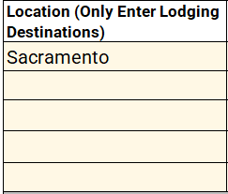

- See the end of this guide for detailed instructions on finding rates.
For Domestic Travel, select the rate of the county of travel (there are 5 choices in the drop-down menu).
For International, AL, HI, and US Possessions Travel, type in the rate.
If the traveler is traveling to multiple locations in one trip, do this for each county that they will spend the night.
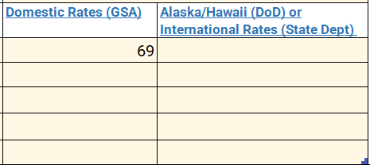

- Under Travel Details, select the county of travel in the drop-down menu for each day of travel.
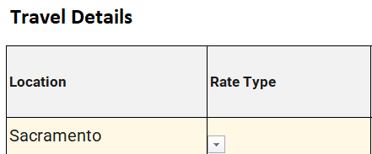

- Select Rate Type from the drop-down menu. Based on the information entered, the form will auto-calculate maximum per diem for that day. First/Last Day Per Diem MUST be selected for the first day and last day of the trip.
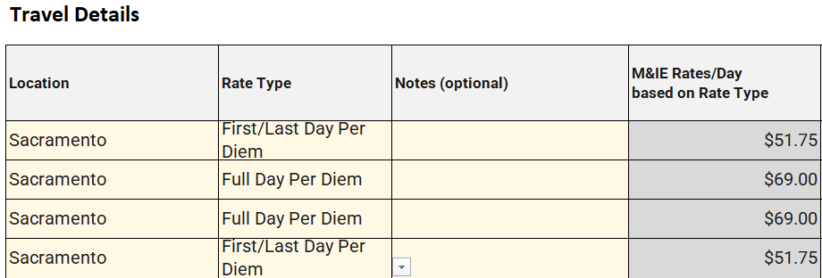

- If meals are provided at the conference, enter “1” in each box that a meal was provided. The form will auto-calculate the pro-rated per diem for that day. The M&IE Total box is what the traveler will receive for meals that day. Even if all meals are provided by the conference, the traveler will still receive $5 for incidentals.
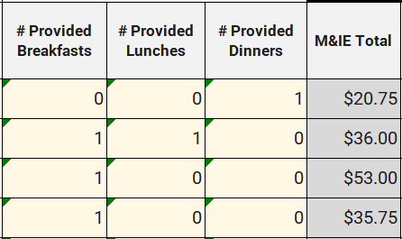

- If the traveler has a personal day during the trip, they can either select “Not Claiming Per Diem” under Rate Type OR enter “1” under Personal Day. The form will auto-calculate to $0 M&IE reimbursement for that day.
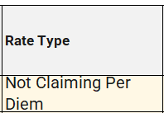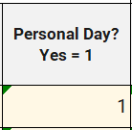

Finding Per Diem Rates:
For Domestic Rates, use this website: https://www.gsa.gov/travel
- Select the state of travel, type in the city, and select the correct fiscal year that the travel took place. If you are traveling to multiple cities/states in one trip, you will do this for each one. Click Search. If there is no rate for that specific county, the Standard Rate will appear.
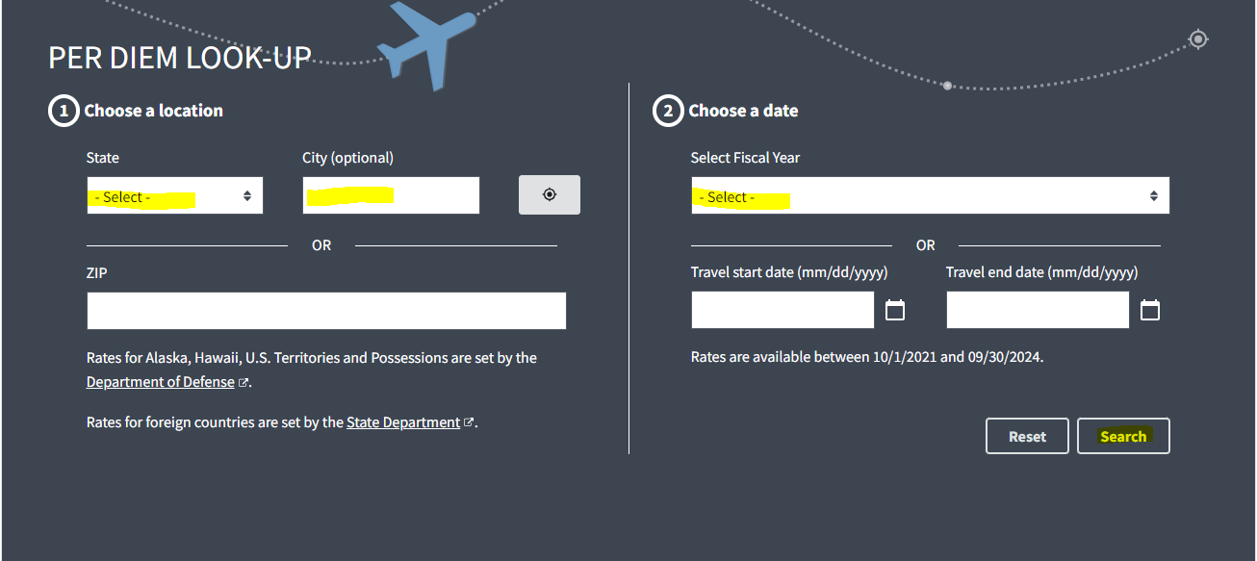

- Scroll down to Meals & Incidentals (M&IE) rates and breakdown.

- M&IE Total is the only number needed. Type this number in the appropriate cell of Step #2 at the top of this guide.
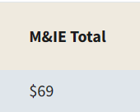

For International Rates, including Alaska, Hawaii, and US Possessions use this website: https://www.travel.dod.mil/Travel-Transportation-Rates/Per-Diem/Per-Diem-Rate-Lookup/
- Select the country/state of travel (example shown below). Click Submit.
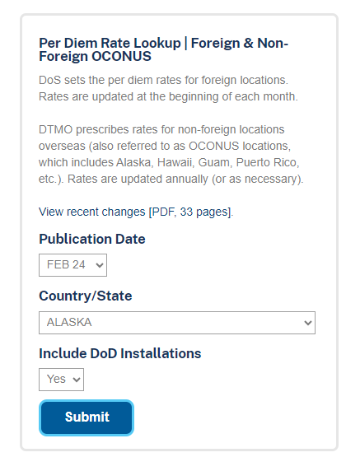
- Find the specific location under Locality. If the traveler’s specific location is not listed, use the “Other” rate.
Combine the Local Meals and Local Incidental numbers. This is your M+IE rate. The expense report form will calculate per diem based on what M+IE rate is entered.
For international travel only: Travelers have the option of using Maximum Lodging Rate instead of hotel actuals.
