How to Properly Tag a Table in Adobe Acrobat

Why tagging a table is important?
Having tagged tables helps ensure that the data listed is listed out in a clear and conscise manner.

A tagged table makes it easier for users to read content in very long tables with repetitive data and also makes it accessible for any viewers who interact with your content that may be using accessible programs.

Step 1: Open the PDF file you want to tag. At the top right navigation panel, select Tools. A dropdown list should appear below the right navigation panel. | 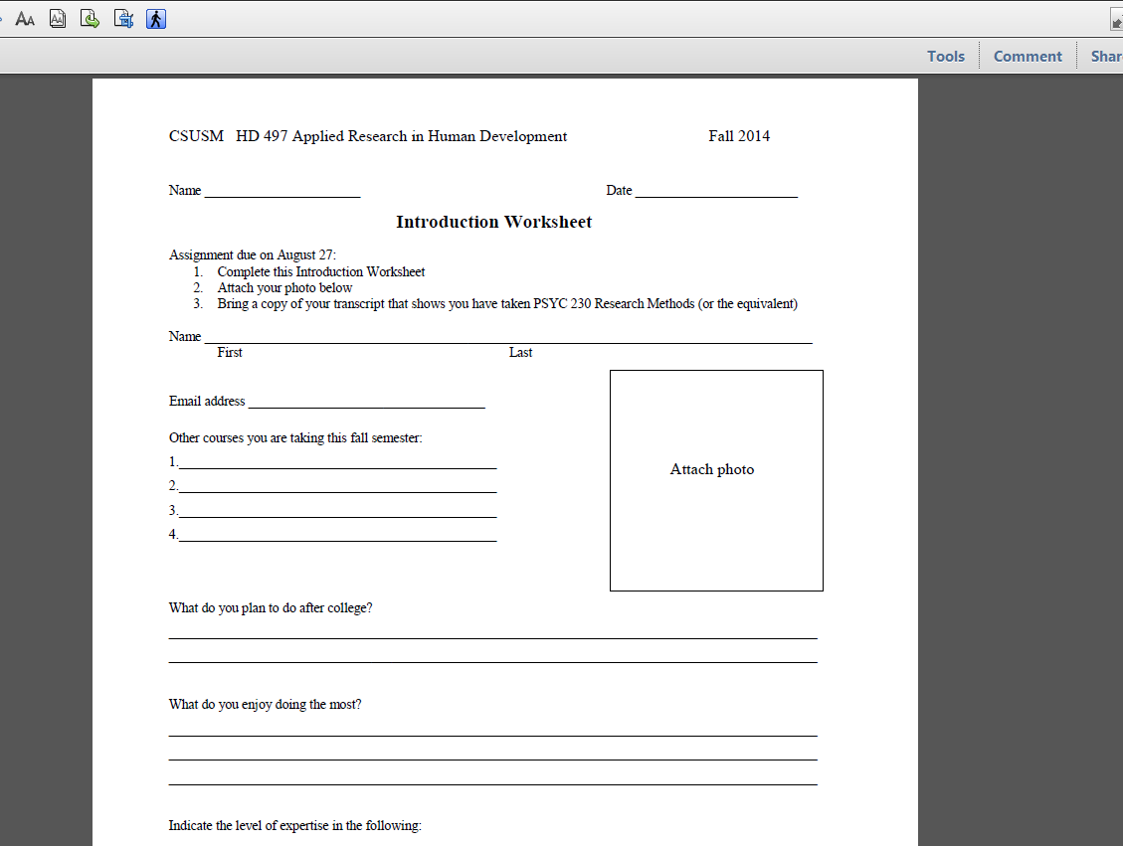
Step 2: From the dropdown, select Accessibility and another dropdown list should open up.
Step 3: Select TouchUp Reading Order.  A Touch Up Reading Order window will open up. | 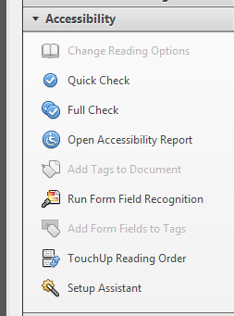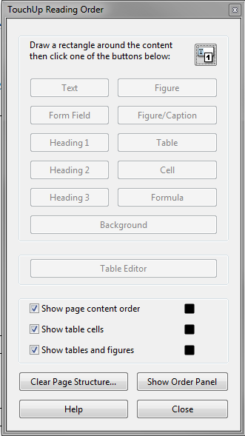
Step 4: Highlight the table you want to tag.
Step 5: After highlighting the table, select the Table button from the TouchUp Reading Order window. |  |  | 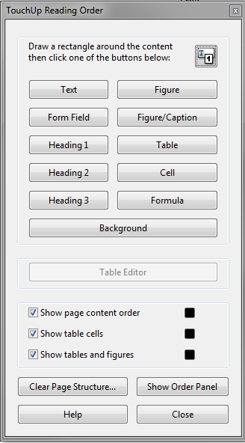
Step 6: A gray box will fill the table with a number in a white box and a text label “Table”. | 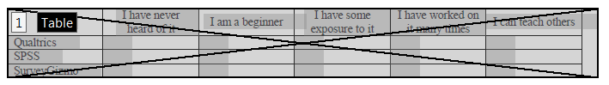
Step 7: Select the white box with a number and select the Table Editor buttom from the TouchUp Reading Order window.  The gray box that fills the table should turn red. This means that you are in Table Editing mode.  A dark colored red cell means that it is a table header. Light colored red cell means it is a table data. | 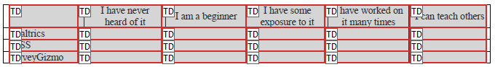  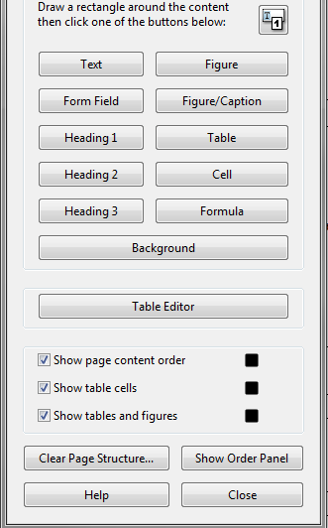
Step 8: Check if the table is correctly tagged. If the header and data cells are all correctly tagged then skip the rest of the steps. | 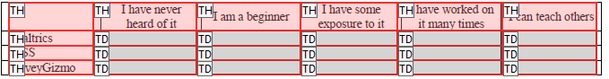
Step 9: Highlight a cell by selecting a cell with your left mouse button or you can highlight multiple cells by holding your left mouse button and dragging your cursor to the other cells you want to highlight. | 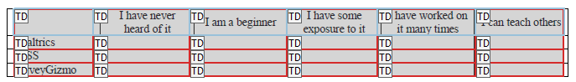
Step 10: After selecting a cell, press your right mouse button and select Table Cell Properties. A new window will popup. | 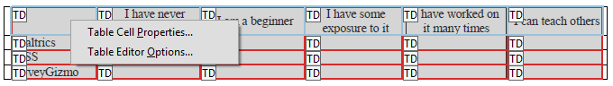
Step 11: Select if the cell is a header or a data.  If it is a header cell, select the Header Cell option.  If it is a data cell, select the Data Cell option.  Select OK. | 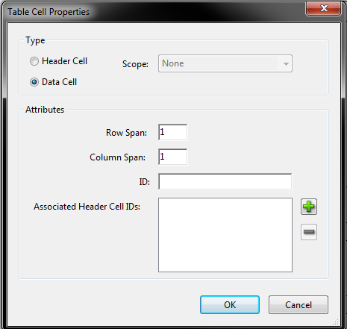
Repeat Step 9 through Step 11 if you need to change another cell to a header or data.

Congratulations, you are done tagging your table!

