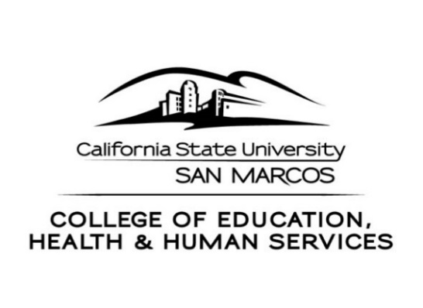
CEHHS Student Services
333. S. Twin Oaks Valley Road
San Marcos, CA 92096-0001 USA

760-750-4277 / 760-750-3539 (fax)
www.csusm.edu/cehhs/studentservices/

SCHOOL OF EDUCATION
Education Specialist and Single Subject Internship Credential

OVERVIEW OF THE ON-LINE RECOMMENDATION PROCESS

Congratulations on your offer of employment! You will need to gather a few items in order to be recommended for an internship credential.

- We will need proof of your employment offer. The employer must be an internship partner with the CSUSM School of Education (SOE) and have a current, valid contract on file. Please have the district Personnel or Human Resources office write a letter on district letterhead confirming their intent to hire, and the assignment start date and type. A copy of the contract is not acceptable.

- Fill out the attached application for the Internship credential, and on it note the type of credential you seek (i.e. Education Specialist or Single Subject). Submit the form to CEHHS Student Services Office in University Hall 221. There is a $25.00 processing fee. Please download to the Credential Evaluation Processing Fee payment form located at: http://www.csusm.edu/cehhs/studentservices/graduate/credfinish.html

- If eligible, we will recommend you for the Internship credential. Once you are recommended, the California Commission on Teacher Credentialing (CTC) will contact you via email. Please follow the instructions provided by the CTC in the email to complete the recommendation process. The CTC charges a credential document fee which can be paid using MasterCard or Visa.

- Intern Eligibility Applicants: If you have not received an offer of employment but you are requesting an evaluation to determine your eligibility for the Internship, please complete the attached application form making sure to check the “Verification of Eligibility” box on page 2 of the application, pay evaluation fee, and submit paperwork to the CEHHS Student Services Office in UNIV 221. You will not be recommended for a credential but you will be evaluated by a credential analyst and notified of your status. The evaluation you receive may be used to verify your internship eligibility to prospective employers.

- SINGLE SUBJECT CANDIDATES ONLY: Please read and sign the attached Early Completion Option form (page 3). Some districts do not allow participation in the Early Completion Option; however, the CTC requires that you be aware of the information and details of the option.

CREDENTIAL EVALUATION APPLICATION & ON-LINE RECOMMENDATION REQUEST

For Education Specialist Internship, Single Subject Internship
or Verification of Internship Eligibility (Single Subject Only)

$25.00 Credential Recommendation Fee
(Refer to Credential Evaluation Fee Payment Form for payment information)

INSTRUCTIONS: Form is fill-in enabled. Download copy to your own computer, open and complete form using computer’s tab key to navigate from field to field.
If filling out by hand, please print.

SS#: CSUSM Student ID#: Date of Birth:

Legal Name: ( )
(as it will appear on credential) Last First Middle Former/Maiden

Street address or P.O. Box City State Zip

Home Ph.: Cell Ph.: Work Ph.:

*Due to problems associated with district firewalls, please use email addresses other than your district email.

Current email address*:

Alternate email address:*

Permanent/Credential Mailing Information:

Street address or P.O. Box City State Zip

PLEASE SIGN, DATE AND RETURN COMPLETED APPLICATION TO:

CEHHS Student Services
Teacher Credentialing - UNIV 221
CSU San Marcos
San Marcos, CA 92096-0001

I authorize CSUSM to release information concerning my credential application to appropriate inquiring school districts and offices and to forward my credential application and supporting materials to the California Commission on Teacher Credentialing for issuance of the credential I have requested.

Signature: Date:

Name: Social Security No.

Request is for the following credentials and/or authorizations: (Check One)
Education Specialist - Mild/Moderate
Education Specialist - Moderate/Severe
Education Specialist - Mild/Moderate and Moderate/Severe
Single Subject - Mathematics
Single Subject - Foundational Mathematics
Single Subject Science - Biological Sciences
Single Subject Science - Geosciences
Single Subject Science - Chemistry
Single Subject Science - Physics
Single Subject - English
Single Subject - Physical Education
Single Subject - Social Science
Single Subject - Spanish
Verification of Internship Eligibility: I have not been offered an internship contract but would like an evaluation in order to verify my internship eligibility to prospective employers.

I would also like to be evaluated for the following authorizations:

Bilingual Authorization: Spanish Emphasis Yes No

Subject Matter Authorization (SMA): (completed worksheet must be included)

Introductory: Specific:

Supplementary Authorization (SA): (completed worksheet must be included)

Introductory: Specific:

(Please complete worksheet for each SMA or SA requested. Additional information and worksheets are located at http://www.csusm.edu/cehhs/studentservices/graduate/sasmaworkshops.html)

California State University San Marcos
College of Education, Health and Human Services
SCHOOL OF EDUCATION

SB 57 Early Completion Internship Option
**Single Subject Requirements**

1. Intern prerequisites needed before employment or recommendation for internship credential:
a. Character Identification (Certificate of Clearance)
b. Basic Educational Skills passage (CBEST or other options available 7/07)
c. Subject Matter Competence (CSET or state approved program)
d. U.S. Constitution
e. B.A. degree from accredited institution
f. English Learner requirements completed

2. Offer of Employment as an Intern by a School District
a. Early Completion option is only available to individuals with an offer of employment from a school district that has a partnership with the CSUSM Single Subject Internship Program

3. Requirements that must be met before admission to the Early Completion Option
a. Teaching Foundations Examination (www.ets.org) California Teaching Foundations: SB57 Pedagogy Tests, available for English, Science, and Mathematics. Exams include:
i. Teaching Methods of Subject Content Category for middle/junior high and high school
ii. Human Development
iii. Learning Differences and Special Needs
iv. Instructing English Learners
v. Reading Instruction
vi. Assessing Student Progress
vii. Classroom Management Techniques

4. Requirements that must be met before Preliminary Credential Recommendation
a. Technology Examination or EDUC 422 at CSUSM.
b. Teaching Performance Assessment (when available).

I have been informed of the SB 57 Early Completion Internship Option

Print Name: Signature:

Date: Student ID:

CEHHS Student Services University Hall 221 (760) 750-4277

