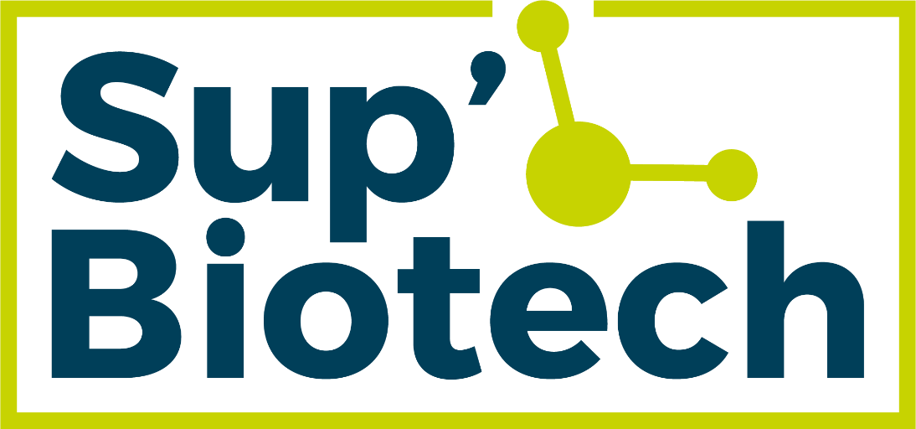

Sup’Biotech International Summer School
Stem cells & Genetic engineering
2022 Edition
July 4 – July 22

SYLLABUS

- Presentation

In 2012, Shiniya Yamanaka was awarded the Nobel prize in Medicine for its discovery that mature cells can be reprogrammed to become pluripotent. In 2018, the very controversial scientist Jiankui He announced the birth of the first GMO babies using the CRISPR/Cas9 technology. In 2020, Emmanuelle Charpentier and Jennifer Doudna were awarded the Nobel prize in Chemistry for their discovery of the genetic scissors CRISPR/Cas9. If you have never heard of these names, let us give it another try: Katalin Kariko. She is the scientist who pioneered the use of mRNA to develop vaccines, the use of which is now well-known in the fight against Covid-19. As you would have understood, stem cell biology as well as genetic engineering have emerged over the past decades as important fields of research and application. These fields include a large panel of research domains such as developmental biology, disease modelling, regenerative medicine, and innovative & personalized therapies.
This Summer School has been designed to provide the tools necessary for mastering stem cell biology and genetic engineering, thus offering a glimpse into some aspects of the medicine of tomorrow. Students will explore what make stem cells unique with a specific focus on their characterization and their function. The progresses in genome editing and the current understanding of various stem cell lines (embryonic and adult stem cells, induced pluripotent stem cells (iPSC)) will be discussed. Concrete examples of ongoing clinical trials and research projects dealing with stem cell or genetic engineering therapies will be given to anchor the Summer School program in today’s public health issues.
This Summer School includes lectures (24 h), hands-on training (26 h), and workshops (12 h) to harness stem cell biology and their biomedical applications.

- Objectives

The Summer School is intended to provide students key concepts about how stem cells and genetic engineering can help scientists and medical doctors to (1) model diseases to better understand them, (2) pave the way for regenerative medicine and (3) develop innovative therapies.
The lecture program will be divided into two parts, the first part dealing with stem cell biology and the second part tackling genetic engineering. Regarding stem cell biology, the lecture sessions will address the following points:
- Stem cells characteristics: self-renewal and differentiation
- Differences between totipotency – pluripotency – multipotency
- Origins of stem cells
- Differences between embryonic and adult stem cells
- Generation of induced pluripotent stem cell (iPSC) lines
- Therapeutic applications of stem cells

Regarding genetic engineering, the lecture sessions will cover:
- How to deliver exogenous genetic materials to human cells
- The different techniques to edit the genome
- The therapeutic applications of genome edition

Hands-on training will allow students to learn how to:
- Handle iPSC line
- Silence a gene in an iPSC line using CRISPR/Cas9 technology
- Generate embryoid bodies from iPSC for organoid generation

Finally, workshops will aim at sharpening students’ critical thinking through an in-depth analysis of cutting-edge scientific publications that will lead to an oral presentation.

- Contents

 | STEM CELL BIOLOGY
Lecture 1:  Introduction to human stem cells | The first lecture will aim at giving students basic knowledge of human stem cell biology, including embryonic, induced pluripotent and mesenchymal stem cells. How to obtain, culture and differentiate stem cells will be discussed. | 3 hours
Lecture 2:  Clinical applications of stem cells | Despite tremendous progresses in drug development, many diseases remain without any curative treatment due to a lack comprehension of their pathogenesis. Consequently, there has been an unfortunate rise in incidences of organ failures, degenerative disorders, and cancers, leading to a need of new therapeutical strategies. Stem cells have unique self-renewal and multilineage differentiation capabilities that could be harnessed for therapeutic purposes. Although several mature differentiated cells have been characterized in vitro, few have been demonstrated to function in a physiologically relevant context. We will focus our discussion on the status of stem cell therapy, the issues surrounding it and its prospects. | 3 hours
Lecture 3:  Example of clinical applications of stem cells | Stem cells display divisive and differentiating abilities that are of interest in the context of regenerative medicine. Some diseases are characterized by the degeneration of cells leading to their loss (e.g., neurodegenerative diseases). The use of stem cells to replace these degenerated cells offers hope in the treatment of such diseases. The invited speaker will present an ongoing clinical trial focusing on this strategy. | 2 hours  Invited speaker
Lecture 4:  From stem cells to organoids | This line is white due to layout needs. Please do not erase. Organoid systems take advantage of the self-organizing properties of stem cells to create various 3D multicellular tissues. Most organoid models only represent single or partial components of a tissue, and it is often difficult to control the cell differentiation type, the 3D organization, and the cell-cell/cell-matrix interactions within these systems. Therefore, we will discuss the generation of stem-cell based organoids, their advantages and limitations, and how bioengineering strategies can be used to improve their viability, reproducibility, and utility. We will also discuss their use in modelling pathologies. A particular focus will be made on the generation of cerebroids. | 3 hours
 | GENETIC ENGINEERING
Lecture 5:  Back to basics | To ensure the complete comprehension of the following sessions regardless of students’ initial formation, this lecture will explore the basis of cellular and molecular biology. Emphasis will be put on genetics. | 3 hours
Lecture 6:  Genome editing | This lecture will give an overview of genome edition. We will present different techniques allowing delivery of exogenous genetic material to cells (electroporation, transfection, transduction) as well as briefly describing genetic engineering techniques (interference RNA, Cre/Lox strategy, CRISPR/Cas9). | 3 hours

Lecture 7:  Genome editing, focus on Cre/Lox and CRISPR/Cas9 strategies | In continuity with previous lecture, this session will focus on both Cre/Lox and CRISPR/Cas9 strategies to edit the genome. The advances, advantages, and limitations of these techniques will be discussed, as well as their prospects.  Time will also be dedicated to discussing genome edition from an ethical perspective. | 4 hours
Lecture 8:  Examples of clinical applications of genetic engineering | Two different applications of genetic engineering serving as therapy will be presented in this session: Car-T cells for leukemia treatment and a gene therapy for Parkinson’s disease using viral vectors.  Car-T cells are patients’ T cells that have been engineered to give T cells the new ability to target a specific cell. This strategy is now used as an immunotherapy treatment for some cancers and is recognized as a better alternative than chemotherapy as the relapsing rate is lower. This kind of strategy is part of the individualized therapies, directly from the patient’s bedside to the lab bench.  ProSavin® is a gene therapy currently in clinical trial for the treatment of Parkinson’s disease. Injected directly into the brain of patients, ProSavin® targets non-dopaminergic neurons to make them express the enzymes responsible for the biosynthesis of dopamine. This strategy allows compensation of the loss of dopaminergic neurons via conversion of non-dopaminergic neurons into dopamine-synthesizing neurons. | 3 hours  Invited speaker  –  To be confirmed

 | PRACTICAL WORK
PW 1:  Handling of iPSC | At the beginning of the summer school, students will be granted a plate of iPSC whose maintenance will have to be performed by the students all along the Summer School. This will be the occasion to learn how to take care, subculture, and freeze iPSC. | All along the 3 weeks
PW2:  Generation of embryoid bodies | Students’ iPSC will be used to generate embryoid bodies. Neural induction will be performed as a first step to generate cerebroids. A growth analysis will be conducted along the remaining time. | 10 hours
PW3:  Genome edition | Gene silencing in human cells using the CRISPR/Cas9 technology will be performed. Genome edition will be performed from A to Z:  - In silico design of the Cas9 short guide and the oligonucleotides that will be used in the next steps.  - Preparation of the constructs for the CRISPR/Cas9 strategy.  - Transfer of the genetic material to human cells.  - Assessment of the edition efficacy via fluorescent microscopy and PCR. | 16 hours
 | WORKSHOPS
Critical analysis:  A corpus of scientific articles | Students will work in groups to analyze a corpus of scientific articles dealing with either stem cells or genetic engineering. Students will then have to present their work. This oral restitution time will also be the occasion to present their practical work results. | 8 hours
Lab visit:  Field trip | A visit of a research laboratory in the field of stem cells or genome engineering will be organized. | 4 hours  Subjected to conditions

Indicated times and order of lectures are for informational purpose and remain subjected to changes until the beginning of the Summer School.

- Evaluation

Upon request, the completion of the Summer School can be graded based on the oral restitution.

