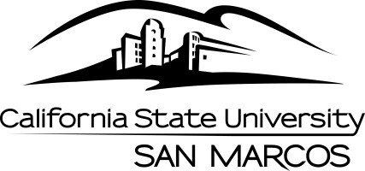
Long-range Academic Master Plan (LAMP) Task Force
MINUTES
October 31, 2014 2-3:30pm MARK 322

MEMBERS PRESENT: A. Althagafi, R. Eisenbach, K. Haddad, D. Kristan, T. Macklin, M. Schroder, W. Schultz, L. Stowell
STAFF PRESENT: K. Roberts

- Introductions
K. Haddad welcomed everyone and thanked them for serving on the task force. The members introduced themselves.

- Charge of the LAMP Task Force

K. Haddad delivered the charge to the task force and pointed out some differences between
the past years and this coming year. He talked about how the task force will interact with other committee’s such as the UCC and BLP. He noted that he and Debbie Kristan, the co-chair of the task force will alternate directing the meetings in the upcoming year.

The work of the task force will help the university prioritize and consider future new programs that should be looked at but have not yet been brought forward, as well as programs that are on the UAMP but have not taken off yet. The task force should consider the needs of the community as well the broader national context.

- Discussion Points

During roundtable discussions many things were noted, including that the recommendations made by the task force are not static and can change at any time. LAMP will consider both Stateside and Self Support initiatives. It appears that the workload will not be as heavy as previously thought since P Forms were being reviewed.

- Process
Goals for the year were discussed. The expectation is that LAMP will come up with a prioritized set of recommendations related but not dependent on the 3 year rolling plan.
- Supporting documents, arguments in favor or against a program and a summary of justifications are important to the process.
- When considering Regional needs, the task force should look at “sister” campuses and get an idea of supply and demand. M. Schroder used the MSW program as an example of collaboration between universities.
- The idea of the task force is not to take college suggestions but quite the opposite. LAMP should be suggesting programs to the colleges.

- Timeline

Meetings will take place every other week and last 90 minutes. Recommendations should be prepped and ready for finalization no later than May 1st. Shooting for closer to April 15th for completion. Working backwards from there, it looks like the timeline for analysis would be February.

Relationship to Senate: After discussions it was agreed that LAMP recommendations
should be presented as “information items” to the EC/Senate. There will be sufficient time in the process to voice any opposition.

- Community Resources

The task force will begin its next meeting by looking into reports by the San Diego Workforce structure and is open to looking at all resources to gain insightful information. Also looking at online resources.

- AGENDA ITEMS FOR NEXT MEETING

- The group decided to take a look at the current reports produced by the San Diego Workforce
- Try to reschedule the meetings that were planned for Winter and Spring break times January 8, and April 2, 2015

- ADJOURNMENT

Doodle poll was sent out and most meetings have been scheduled. Please let Kris know if you need any more information.

