Pioneers traveled by land and sea, setting out to discover their fortunes in the Gold Rush Country. These routes were by land and by sea. Read the descriptions below to become the “specialists” on the most common routes traveled, and the life of the travelers along the way.

Travel By Land
Trails West
Most people from the mid west or the east caught by “gold fever” traveled by land on the Oregon-California or the Mormon trails. It was less expensive to travel by land than by sea. A family of four had to pay $600 to $700. The trailheads (or beginning of the trail) began in Iowa and Missouri. Gold-seekers, (over 32,000) traveled through present day Nebraska, Wyoming, Idaho and Nevada.
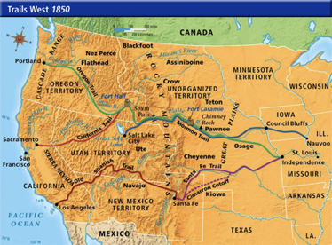

The overland trip was a distance of 3,000 miles and took from four to six months. Most took a steamboat up the Mississippi River to get to the trailhead. It was considered a good day if the ’49ers could travel ten to fifteen miles. Pioneers could stop at posts along the way to replenish food, tools and other supplies. Sometimes the wagon train before them had cleaned the forts out before they arrived! They had to be very careful to leave at just the right time as the freezing temperatures through the mountains, and the scorching heat through the desert could make travel impossible.

Supplies
On the trail, pioneers had covered wagons. Some rode in the wagons, and others walked. They were very limited in space and only brought supplies that
were necessary: a cooking stove made of sheet metal, cows, bacon, ham, rice, dried fruit, molasses, packed butter, bread, coffee and tea, tools for mining, farming and repairing wagons, vegetable and flower seeds, medicines, quilts, musical instruments, guns, ammunition, needles strengthened for mending clothes and tents, bedding, including buffalo robes, waterproof India rubber blankets to keep things dry, and lock chains to hold wagons back on steep hills.

Life on the Trail
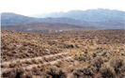
Supplies were hung from hooks on the inside of the hoops of the covered wagon. Others were kept in a special box that hung from the rear of the wagon. A bucket of grease was hung between the wheels to lubricate them. Some pioneers stored eggs in flour barrels so that they would not break.

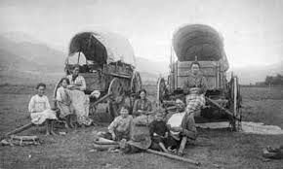
Animals were “driven” by shouting and cracking whips over their heads; they were not hit! The ride was very rough and bumpy; many people chose to walk instead of sit in the uncomfortable wagon, which didn’t go very fast. In fact, after a few hours on the rugged trail, sometimes a ball of butter would form in the center of a can of milk stored in the wagon! Life on the trail was very harsh. Pioneers had to trek over the Rocky Mountains, through the barren deserts of Nevada, and then cross the towering Sierra Nevada Range. Many 49’ers were afraid of native Americans attacking them, but it rarely happened.

Sickness
A cholera epidemic killed young and old people on the trail, and dysentery was a common sickness from drinking dirty water. The most common cause of death was by diseases and sicknesses that also included mountain fever, pneumonia and diphtheria.

Travel By Sea
People traveling by ship had a choice between two routes. They could travel from the East Coast to Panama and cross the jungle to catch a boat to California on the other side. Travelers who took the longer route sailed around Cape Horn at the tip of South America, and headed up the Pacific coast to San Francisco.

Winter storms made it difficult to travel over land. Therefore, travel by sea was an option for many. Between 1848 and 1849, 762 ships left Eastern ports for San Francisco. This made San Francisco the third most important port in the nation after New York and Boston.

The Journey Around Cape Horn
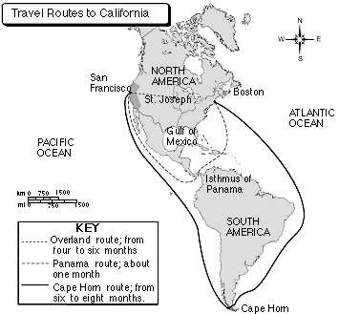
If travelers took the route from the east coast of the United States around Cape Horn the trip could take from six to eight months. The cost was from $100 to $300 dollars each. They would travel some 14,000 miles in all.

By Sea, through Panama and by Sea Again
The route through Panama was faster but more expensive. It cost between $200 and $400 dollars for each traveler. Once the Forty-Niners reached Panama by boat from the east coast they had to cross the jungle on mules to get to the Pacific Ocean. Traveling through the jungle through Panama meant insects, poisonous snakes, and diseases such as yellow fever, malaria or cholera.

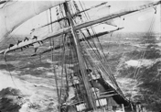
When sea travelers from both routes arrived on the Pacific Ocean, they often found the ships to San Francisco were full. They may have had to wait months for a ship, or pay a bribe to get on a ship leaving sooner. Also, the boats leaving Panama City were very crowded. “They were filled to crammation”, as one ship’s captain said. If they did not have to wait too long for their boat to San Francisco this route could take a little over a month. Some stayed in San Francisco and became settlers, and San Francisco boomed. In 1850, the population of the state of California grew from 18,000 to 92,600.

Life on the Sea
It was a difficult trip on both routes, with rough storms, sea sickness and a lack of fresh water, fruit and vegetables. They ate salt preserved meats, fish, dried beans, rice and potatoes. One of recipes was hash made of salted meat, potatoes and sea biscuits or dried bread softened with water. They added molasses, vinegar and spices to flavor bad water. This was called switchel. In general the food was awful! After a few weeks the fresh food was gone. One passenger described two bugs for every bean and wormy moldy bread.

Advertisements for ship tickets promised luxury accommodations and hours of carefree pleasure. Many travelers ended up on whaling ships with people crammed in where the blubber and oil were once carried. Some were so crowded people had to sleep standing up. More than 500 ships set out for California in 1849. Many gold seekers from Europe took this route once they had landed in New York or Boston. In addition, many people from the east coast took these routes rather than the overland trail.

Many ships had whole crews head off to the Gold Rush as soon as they pulled in the harbor. This left abandoned vessels in the harbor. These ships were dragged up on land and used for housing and business buildings. Some of the travelers who were broke, could not go any further, and lived in these ships as they were docked. Enterprising migrants set up businesses to furnish, feed, and entertain the region’s growing population. Merchants were more likely to prosper than prospectors.

Sacramento and its’ Busy Riverfront
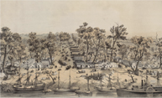
Rivers linked the gold-mining regions with San Francisco and were very important to mining operations. Steamboats were shipped around Cape Horn in 1849 and 1850. They ran the steamboats on the inland waterways between San Francisco and Sacramento, transporting people and supplies to the gold rush area. Some of these steamships that came from Boston made an amazing $600,000 carrying supplies and people their first year in California.

Sources:
http://www.calgoldrush.com/graphics/byland.html#storylink=cpy
http://goldrushofcalifornia.weebly.com/travel-routes.html
http://www.legendsofamerica.com/we-californiatrail.html
http://www.legendsofamerica.com/ca-goldrush.html
https://www.nha.org/library/hn/HNjensen-rounding.htm
http://www.kidport.com/RefLib/UsaHistory/CalGoldRush/ComingBySea.htm
http://americanhistory.si.edu/onthewater/exhibition/2_4.html

