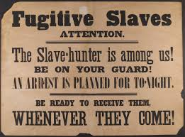

The Compromise of 1850
California became the 31st state, and a “free” state! To balance the “slave power” New Mexico and Utah remained as territories, not as states of the Union.

Fugitive Slave Act

An important part of the Compromise of 1850:

If a slave escapes, he or she is considered a fugitive.

- Fugitives may be seized with a warrant from the court, or seized and taken to court, even without a warrant.

- African Americans accused of being fugitives could not testify in court.

- If any person rescued the fugitive, he would be fined $1,000 and put in prison for up to 6 months.

What questions need to be asked?

How can the law help you?

How does the law in this case make the situation more difficult?

****Listen to the next podcast for more facts in the case!

